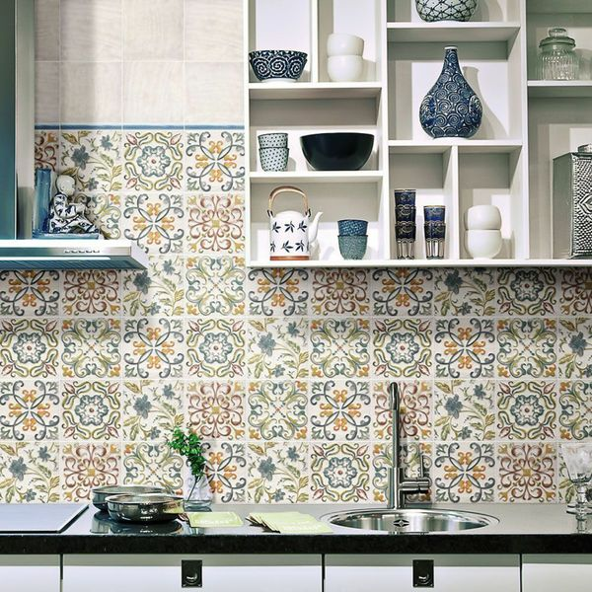**Lucy Floweret Decor Tile:**

## **Product Description**

Create a stylish new look in your kitchen or bathroom by introducing these captivating Lucy Floweret Ceramic Gloss Decor. As part of our selection of vintage Magisterial Chelsea tiles, they come in 5 different designs, which are distributed randomly to ensure a good mix. They consist of an off-white background with decorative floral-esque scrolls in a mix of blue, green, orange and red. They have a shimmering gloss finish. To take a closer look, why not order a sample tile?

## **Product Info**

* Product ID: 13612
* Tiles Per SQM: 44.444444444444
* Sale by: Per SQM
* Size: 150x150x7mm
* Weight: 0.31 KG
* Material Type: Ceramic
* Finish: Gloss
* Colour: Multicolour
* Suitability: Walls
* Grade: No
* Rectified Edge: No
* Underfloor Heating: No
* Document: [View All Designs](https://m2.wallsandfloors.co.uk/media/amasty/amfile/attach/DocumentLucy%20Tile%20PDF1405523786.pdf)
* Thickness (mm): 7